### **Yu F, Shang J, Hu Y, Milford M. NeuroSLAM: a brain-inspired SLAM system for 3D environments. Biol Cybern. 2019 Dec;113(5-6):515-545. doi: 10.1007/s00422-019-00806-9. Epub 2019 Sep 30. PMID: 31571007.**

3D grid cells + multilayered HD cells 4DOF pose (x,y,z,yaw)

**their robots exploring 3D environments are really exploring a series of planes -> it wouldn't supprose me if there were instances of place field repetition in this environment -> like column shaped fields as seen by jefereys

3D head direction cells respondto a particular combination of azimuth x pitch thus represent-ing the direction of the head vector in 3D space (Finkelsteinet al.2015,2016)

multidimentional continuous attractor network

many recurrent connections + weighted excitatory and inhibitory lead to activity bumps

** multilayered experience map -> i suppose usefull for linking of planes?

experience map has nodes which are experiences and transitions between them which contains the 4DoF change in pose

still has these conjunctive pose cells which are combination of gris cells and HD cells now just have 4DOF pose

READ MORE HUGE PAPER

### **Erdem UM, Milford MJ, Hasselmo ME. A hierarchical model of goal directed navigation selects trajectories in a visual environment. Neurobiol Learn Mem. 2015 Jan;117:109-21. doi: 10.1016/j.nlm.2014.07.003. Epub 2014 Jul 29. PMID: 25079451.**

### **O. Struckmeier, K. Tiwari, M. Salman, M. J. Pearson and V. Kyrki, "ViTa-SLAM: A Bio-inspired Visuo-Tactile SLAM for Navigation while Interacting with Aliased Environments," 2019 IEEE International Conference on Cyborg and Bionic Systems (CBS), Munich, Germany, 2019, pp. 97-103, doi: 10.1109/CBS46900.2019.9114526.**

vision sensitive to lighting changes etc and also problem with viually ambiguous environments -> mazes each corridor looks the same

** something to think about is odor cues -> place field rotation must clean the maze or else odor left by the rat will indicate the rotation

** scent mrkign arround doorways and salient things

** scent gives information about somewhere they have already been

pose cells represented by a continuous attractor networl -? resemble fgrid cells +head direction

pose estimate is energy packet which is moved through energy injection from odometry adn local view cells

LV cells store distinct visual scenes ans a template

experience map is a topological representation of the robots environment generated from pose cell and LV cell

an experience = pose + LV <x,y,theta,V>

initially robot relies on odometry which is subject to error

when loop closures events happen where robot revisits a location and recognises it -> do graph relaxation to bring odometry based pose estimate and current pose exeprience in line

whisker ratSLEM is a 6D tactile algorithm -> input from whicker array instead of camera

* generate topological map of object exploration with 6DoF nodes

tactile SLAM is based on whisker ratSLAM

uses #D pose cell network istead of 6D

* generate 3D tactile templates equivalent to the visual tempates

*Rapid Cessation of Protraction - stop whisking of the whisker when it comes into contact with a surface*

ViTa combination of both of these

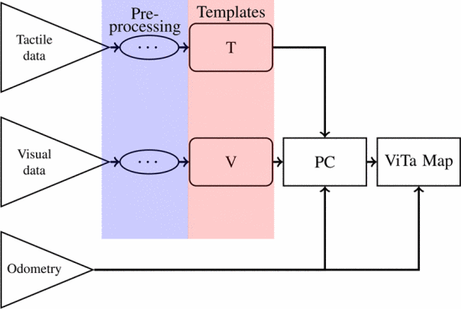

compare both vision and tactile experience to old templates - find closest match + error and determine if novel

weighted sum of visual and tactile error

** if there are two cameras do you do some sort of depth perception? or do you get two side views like a rat

**does the experience map have any grounding in biology? hippocampus major structure for episodic memory -> location of place cells -> some sort of memory of location especially id the firing is to do with salience

### **R. Kreiser, G. Waibel, N. Armengol, A. Renner and Y. Sandamirskaya, "Error estimation and correction in a spiking neural network for map formation in neuromorphic hardware," 2020 IEEE International Conference on Robotics and Automation (ICRA), Paris, France, 2020, pp. 6134-6140, doi: 10.1109/ICRA40945.2020.9197498.**

### **M. Salman and M. J. Pearson, "Advancing whisker based navigation through the implementation of Bio-Inspired whisking strategies," 2016 IEEE International Conference on Robotics and Biomimetics (ROBIO), Qingdao, 2016, pp. 767-773, doi: 10.1109/ROBIO.2016.7866416.**

### **T. Assaf, E. D. Wilson, S. Anderson, P. Dean, J. Porrill and M. J. Pearson, "Visual-tactile sensory map calibration of a biomimetic whiskered robot," 2016 IEEE International Conference on Robotics and Automation (ICRA), Stockholm, 2016, pp. 967-972, doi: 10.1109/ICRA.2016.7487228.**

### **M. J. Pearson, C. Fox, J. C. Sullivan, T. J. Prescott, T. Pipe and B. Mitchinson, "Simultaneous localisation and mapping on a multi-degree of freedom biomimetic whiskered robot," 2013 IEEE International Conference on Robotics and Automation, Karlsruhe, 2013, pp. 586-592, doi: 10.1109/ICRA.2013.6630633.**

Shrewbot - 3D array of whiskers

Adds motor at base of whisker - to emulare activie whisking bahaviour (increasees spatial coverage)

whiskers at front shorter and behind longer

each whisker module has microcontroler

still have 2D deflection data

whisker sensory information Wn = {w1,w2,...,w18}n (nth sample) wi = (wx,,wy,wz) for whisker i

whisker sensory information is mapped to an egocentric map around shrewbots head

whicker makes contact with obstruction -> increased tactile salinence of that point in egocentric space

nose of robot is directed to the most salient point -> at the end of each whisk

add non uniform noise to saliency amp and get exploration, wall following and novelty seeking behaviour

collect video, odometry and whiker sensor data

pose = [xn,yn,on] where on is head direction

localisation like before with standard particle filter (represents posterior probability of pose in a 2D grid occipamcu map

each particle maintains esitmate of the pose of the robot in a local map - each celll represents a specific place

updated at the end of each whisk

odometry data used to update pose easimation

map of occupancy likelyhood - no whisker connections = low likelyhood of occupancy in that position

has period of sensory deprivation when the robot expores featurless floor and whikers do not make an contacts -> must rely of odometry

### **M. J. Milford, G. F. Wyeth and D. Prasser, "RatSLAM: a hippocampal model for simultaneous localization and mapping," IEEE International Conference on Robotics and Automation, 2004. Proceedings. ICRA '04. 2004, New Orleans, LA, USA, 2004, pp. 403-408 Vol.1, doi: 10.1109/ROBOT.2004.1307183.**

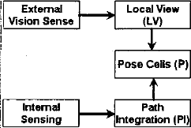

wheel encoder gives path integration information

camera 'vision' converted to local view representation - store familiar views and compare new views to see if familiar

pose cells - arranges in competetive attractor network

units excite other close by units and inhibit tfurther away ones

get clump of activity 'activity packet'

inject activity close to the packet then packt moves towards this activity

inject activity further away and get competition

pose cells represent the beliefs about orientation and position ( combination of place/grid cells and HD)

* if have separate networks get alliasing problem
  + when seeing the ame land amrk from two differnt directions will have two posible HD and two possible locations each of which could go with the other -> 4 possible poses (disaster)
  + so represent (x,y,theta) together

Path integration

* each cell approx 0.25m×0.25m in area and approximately 9in bearing

Local view

vision procession reports distance and relative bearing to coloured cilinders + uncertanty

3D matrix axes: distance colour and bearing

LV cells become associated with simultaneously active pose cells - strengthen weighted conneciton

simulate 700 local view cells and 180000 pose cells (800000/1.3x10^8 connections with non-zero weights)

familiar scence -> LV cells project energy along weighted connections to pose cells -> chanhe weight with limit on how much can change (this limit strikes balance between maintaining current pose estimate and remapping in order to deal with ambiguity)

competetive attractor dynamic make sure total activity remains constant. -> pose cells are probability distribution of pose

1. ecitatory ipdat to each xy layer
   1. 2D gausian to create weights connecting each cell P to al other cells in the layer
2. excitatory update between x,y layers
   1. 1D gausian to form weihgt dJ
3. global inhibition
   1. gentle - competing packets exist for some time to gather more visual reinforcement
4. normalisation of pose cell activity
   1. maintain total activation by increasing or decreasing all wights my a factor

no cartesian representaiton of environment - just topologically consistent

### **C. Fox, M. Evans, M. Pearson and T. Prescott, "Tactile SLAM with a biomimetic whiskered robot," 2012 IEEE International Conference on Robotics and Automation, Saint Paul, MN, 2012, pp. 4925-4930, doi: 10.1109/ICRA.2012.6224813.**

unlike vision whiskers only give local informaiton

* but can give information of the orientation of objects

whiskers 140mm sensing at the base (whisker at baseabove hall effect sensor

* get magnetic field 2D output
* horizontal and vertical strain data from upto 28 whiskers 2kHz

iRobot Create + netbook connected to serial port

netbook for texture and shape recognition

movement controlled by finite state machine

* robot moves forward FWD1 unit it hits something Hit1
* then moves closer until another whisker hits Hit2 or too much strain on the shisker
* then robot reverses and turns
  + angle is a combination of small gausian to encourage wall following and large gausian to encourage exploration of other part of the arena

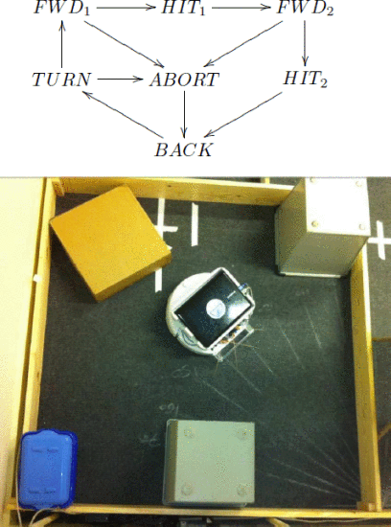

multi whisker contacts -> ange between them gives angle of surfect

OR with multiple whikers build templates of different angles but driving into a wall at different angles -> then determine angle s on new surfaces wy matching the templates -> this method doesnt depend on geometry which depends on knowledge of exact relative whisker position which is inacurate

use multi whisker ibnformation for classification (8 dimentional data, two axis of deflection for 4 whiskers)

populate grid map with 1 if object present and 0 if no object present (with uncertainty sclae)-> gompared to ground truth map for measure of performance